MINNESOTA DEPARTMENT OF PUBLIC SAFETY
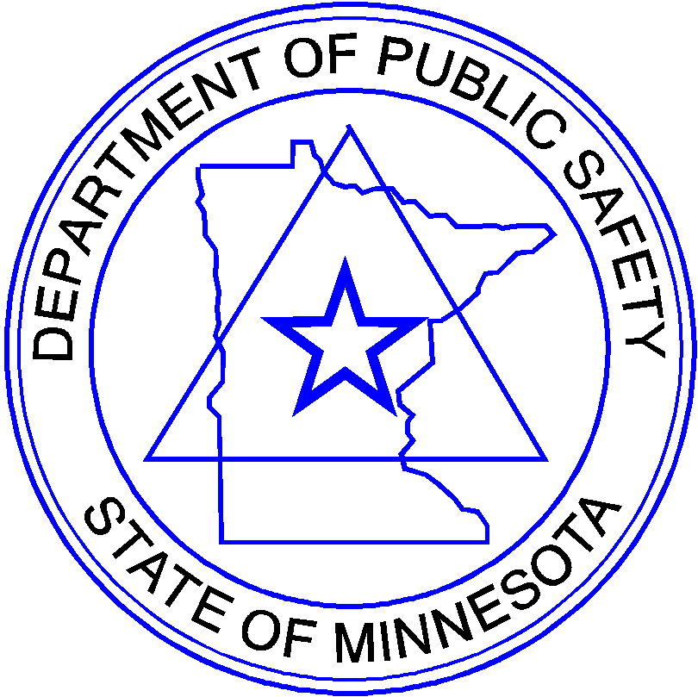

Alcohol &
Gambling
Enforcement

Bureau of
Criminal
Apprehension

Driver and Vehicle Services

Emergency Communication Networks

Fiscal & Administrative Services

Homeland
Security and
Emergency
Management

Minnesota
State Patrol

Office of
Communications

Office of
Justice Programs

Office of Pipeline Safety

Office of
Traffic Safety

State Fire
Marshal

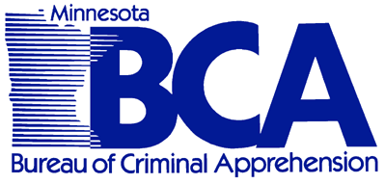

Bureau of Criminal Apprehension
1430 Maryland Avenue E., St. Paul, Minnesota 55106
Phone: 651/793-7000 FAX: 651/793-7001
Website: bca.dps.mn.gov
EQUAL OPPORTUNITY EMPLOYER

November 5, 2012

To: Purchasers of BCA criminal history data
From: BCA Criminal History Unit

Re: Changes to criminal history data display

The Bureau of Criminal Apprehension (BCA) will soon change the way it formats data provided in its monthly data dumps.

The BCA in March, 2013 will begin providing the data in XML format based on the Minnesota Criminal Justice Event schemas. The exact schema is still being finalized and we’ll have more information for you about this by the end of the year.

The change will also mean the inclusion of additional data elements. The final list of additional elements is still being worked out.

Watch for an update later this year.

Sincerely,
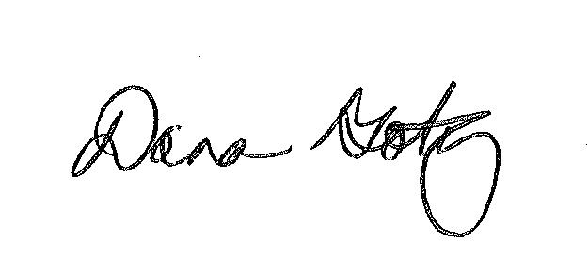
Dana Gotz
Executive Director, Minnesota Justice Information Services

